VMware Identity Manager Smart Card Authentication

Configuration Guide

Version 3.3.x

Contents

Version History 3

Overview 4

Summary 4

Requirements 4

Browser Support 4

VMware Identity Manager Configuration 5

Install DoD issued or CA signed certificates 5

Directory Configuration 5

Certificate Authentication Adapter Configuration 6

Access Policy Configuration 8

Identity Provider Configuration 9

Test Login Process 10

Troubleshooting 11

Where are the Logs? 11

My browser is not prompting me for certificates 11

After HA Cluster scale-out of Workspace One Access, Smart Card (CAC) authentication fails. 11

Glossary 14

# Version History

|  |  |  |  |
| --- | --- | --- | --- |
| **Date** | **Version** | **Description** | **Author(s)** |
| 11/19/2020 | 1.0 | Initial Draft | Adam Bluhm, Ryan Lakey |

# Overview

## Summary

VMware Identity Manager 3.3.x can be used as an identity and access management solution for vRealize Suite and NSX-T products and doing so brings along the capabilities of vIDM which include certificate based authentication. The focus of this document is the configuration of certificate-based authentication in vIDM for its use with these products. This feature is biased towards Department of Defense Common Access Card (CAC) implementations but may fit other environments as well. This document will not tell you how to implement PKI, only how to integrate vIDM into an existing PKI.

This guide is written for system administrators familiar with the products involved and their terminology.

## Requirements

* vIDM 3.3.x as deployed by vRealize Suite Lifecycle Manager 8.x as a single node or cluster.
* OCSP and/or CRL Distribution Points are available for certificate revocation verification.
* If a vIDM cluster is deployed that a load balancer and proper cluster configuration has been done.
* DoD issued certificates are available or an internal authorized CA is available to issue certificates.

This deployment assumes that an enterprise PKI has been deployed. The end user is responsible for having the necessary tokens/cards and middleware so their certificate can be presented to the browser. The certificate selected by the user for authentication must meet the following requirements:

* The certificate will need to have a User Principal Name (UPN) in the Subject Alternative Name (SAN) extension. The UPN needs to correspond to an active directory account.
* The certificate will need to have “Client Authentication” as one of the “Application Policy” or “Enhanced Key Usage” purposes. If the certificate does not have this usage, then it will not be selected by the browser for authentication.

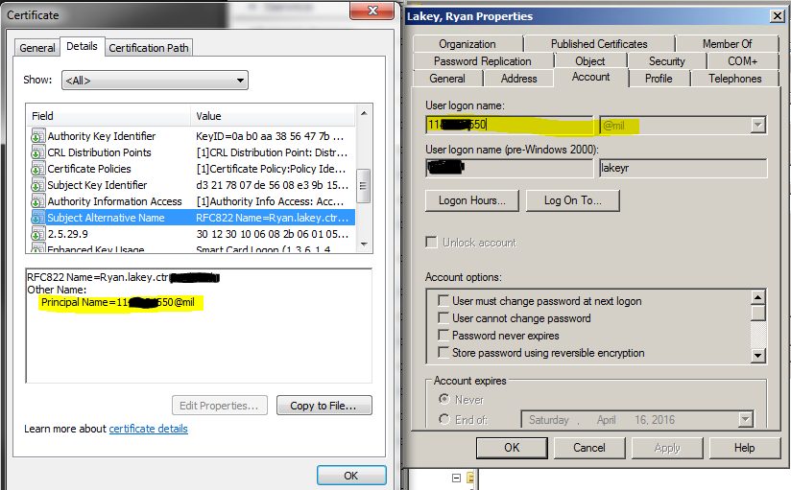

**FIGURE 1:** Example Certificate and Active Directory Account

## Browser Support

For certificate-based authentication

* Chrome, Internet Explorer, Microsoft Edge
* Firefox is not supported without additional plugins

# VMware Identity Manager Configuration

## Install DoD issued or CA signed certificates

1. Login to the vIDM appliance configurator by going to *https://<appliancefqdn>:8443* and clicking the “Appliance Configurator” link.
2. Click on Install SSL Certificates >> Server Certificate tab
3. Choose custom certificate and upload the custom certificate here in concatenated PEM format consisting of the issued certificate, subordinate CA cert if any, intermediate CA cert if any, and the root CA certificate. Also supply the private key including the BEGIN and END blocks save.

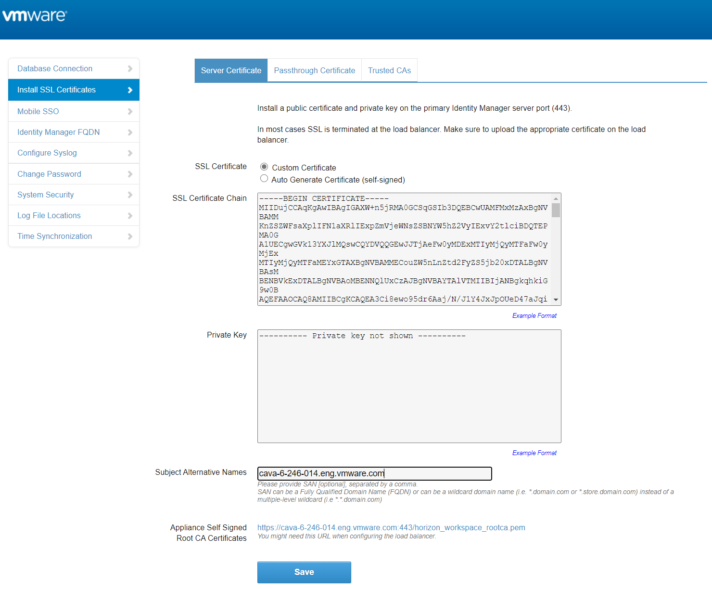

**Figure 2:** Server Certificate Installation

1. (Optional) Repeat the steps on the Passthrough Certificate tab but this may be unnecessary in some configurations such as a single node or a cluster that is not terminating SSL on the load balancer.
2. Repeat for any additional nodes for a cluster deployment.

## Directory Configuration

1. Login to the vIDM appliance configurator by going to https://<appliancefqdn>:8443 and clicking the “Identity Manager Admin Console” link or it can be accessed by logging into https://<appliancefqdn> as a user with administrative rights and then choosing “Administrative Console” from the drop down under your username.
2. Navigate to the Identity & Access Management tab and choose Directories.
3. Click on the directory name for your Active Directory directory.
4. Ensure UserPrincipalName is selected for the Directory Search Attribute.

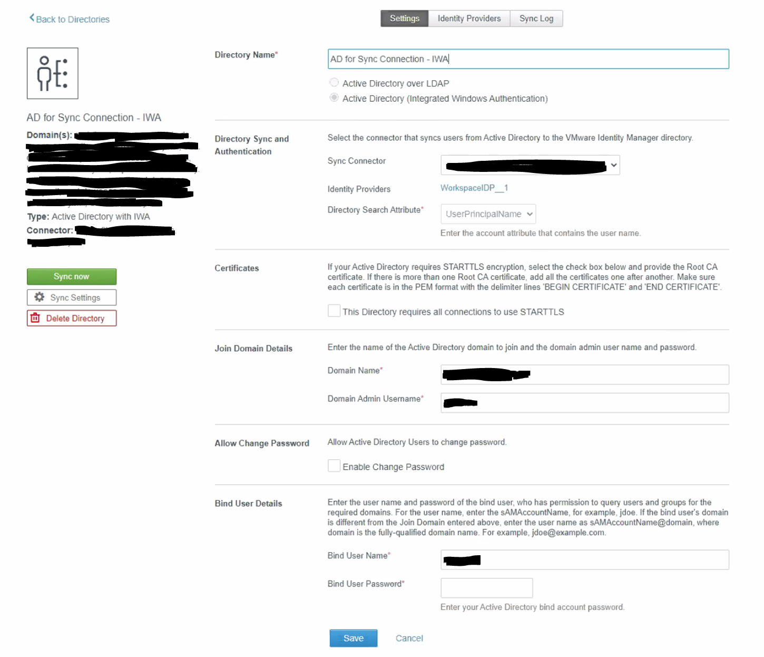

**Figure 3:** Directory Configuration

## Certificate Authentication Adapter Configuration

1. Login to the vIDM appliance configurator by going to https://<appliancefqdn>:8443 and clicking the “Identity Manager Admin Console” link or it can be accessed by logging into https://<appliancefqdn> as a user with administrative rights and then choosing “Administrative Console” from the drop down under your username.
2. Navigate to the Identity & Access Management tab and click the setup button on the top right and choose Connectors.
3. Click on the worker link for the target connector.
4. Select the Auth Adapters tab then click on the CertificateAuthAdapter link.
5. Click the checkbox to enable the Certificate Adapter.
6. Upload the subordinate, intermediate, and root CA certificates for the issued Smartcard certificates used in the environment or optionally just upload all DoD CA certs.

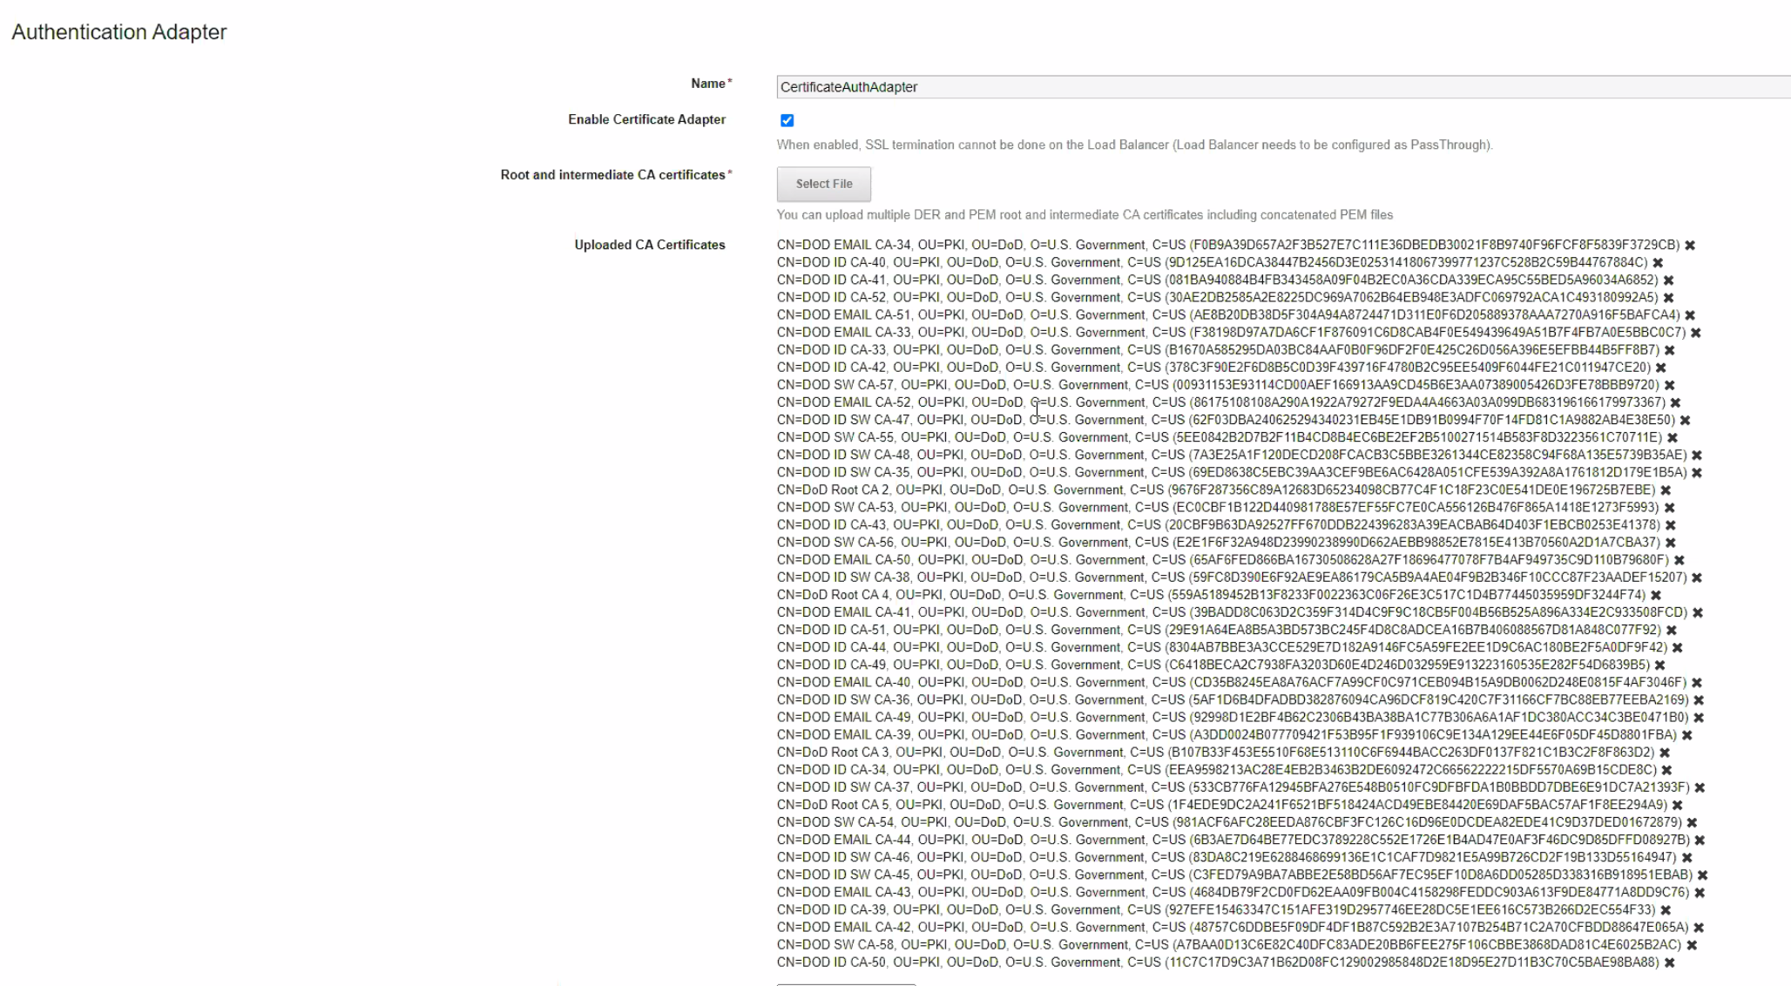

**Figure 4**: Certificate Auth Adapter Configuration 1

1. (Optional) Enable certificate revocation while not required for this to work will be required by STIG and is a good idea anyway. OCSP is preferred over CRL also and if your OCSP responder has a certificate it must be uploaded here too.
2. Enable the Consent Form option and input the standard DoD login banner in the Consent Form Content box.
3. Save and repeat for any other connector appliances in a clustered deployment.

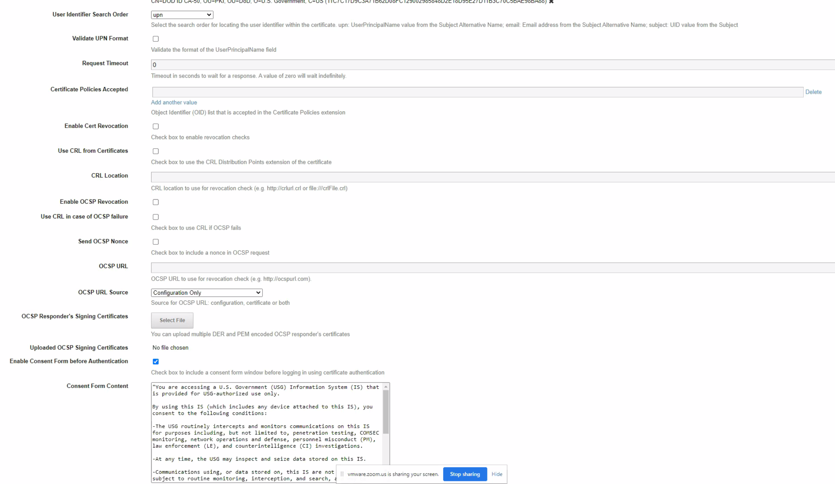

**Figure 5:** Certificate Auth Adapter Configuration 2. Note revocation configuration not shown.

## Access Policy Configuration

1. Login to the vIDM appliance configurator by going to https://<appliancefqdn>:8443 and clicking the “Identity Manager Admin Console” link or it can be accessed by logging into https://<appliancefqdn> as a user with administrative rights and then choosing “Administrative Console” from the drop down under your username.
2. Navigate to the Identity & Access Management tab then select Policies
3. Edit the default access policy or create a new one
4. Under configuration click on the 3 dots for the network range for Web Browsers
5. For “then the user may authenticate using” select Certificate
6. Configure fallback methods as needed for local directory or password authentication if certificate authentication fails or is unable to be performed due to OCSP unavailability or other environmental issues.
7. Save and exit.

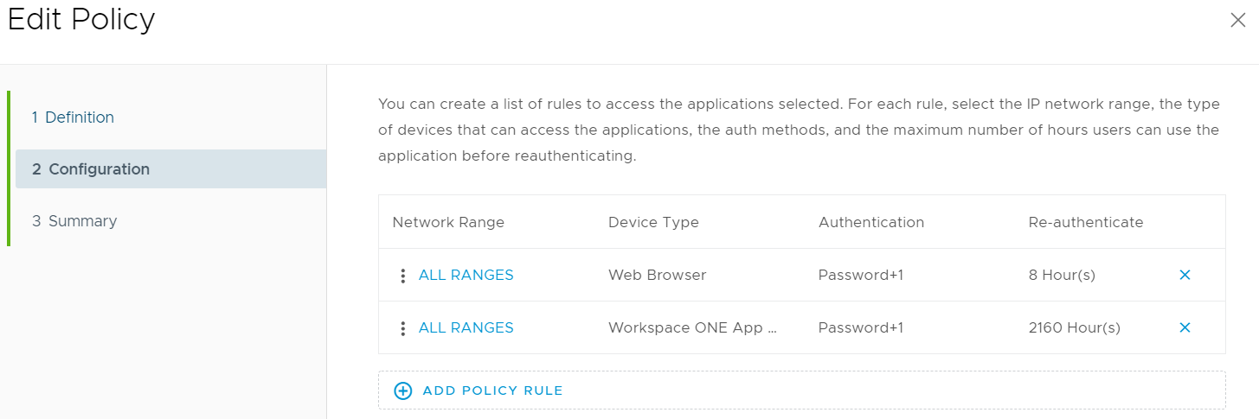

**Figure 6:** Access Policy Configuration 1

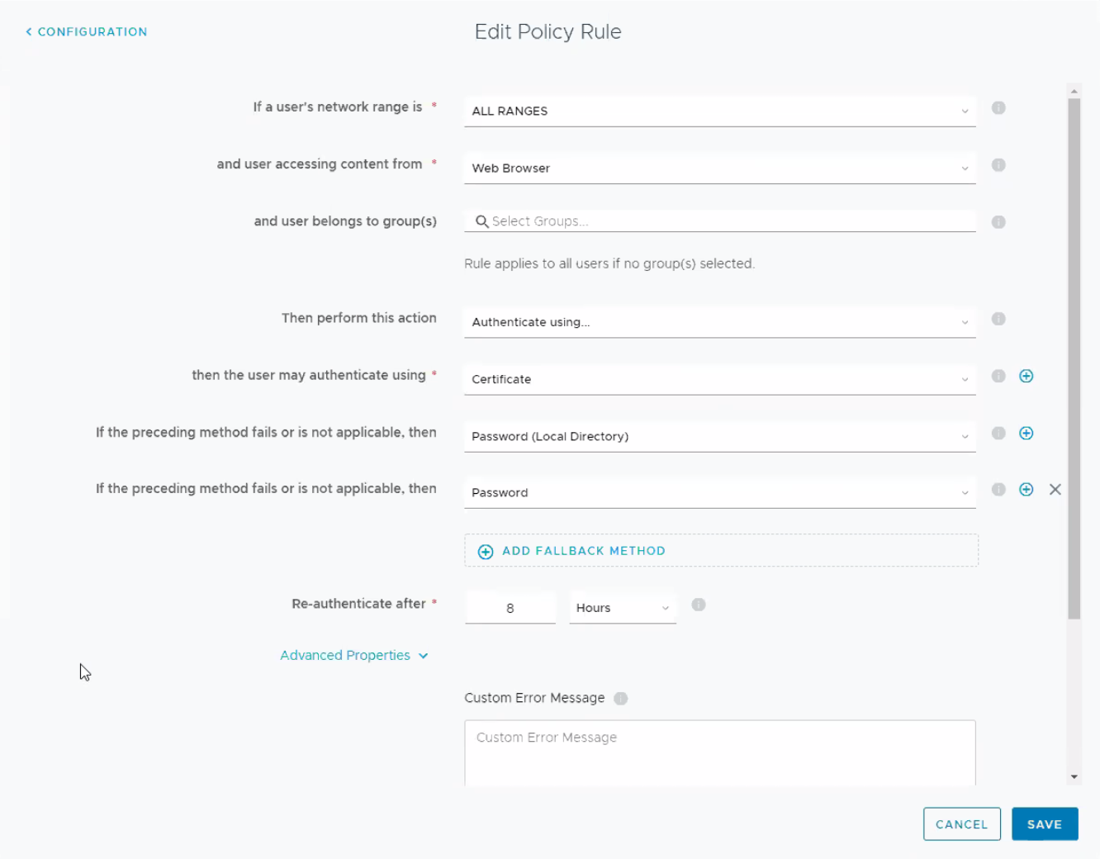

**Figure 7:** Access Policy Configuration 2

## Identity Provider Configuration

1. Login to the vIDM appliance configurator by going to https://<appliancefqdn>:8443 and clicking the “Identity Manager Admin Console” link or it can be accessed by logging into https://<appliancefqdn> as a user with administrative rights and then choosing “Administrative Console” from the drop down under your username.
2. Navigate to the Identity & Access Management tab then select Identity Providers
3. Select the default “WorkspaceIDP_1” IDP or if a different one has been created and in use select that one.
4. Verify Certificate is shown under Authentication Methods and the connectors you configured earlier are listed.
5. Under IdP Hostname verify the appliance name is shown in a single node deployment or the cluster name in a clustered deployment.

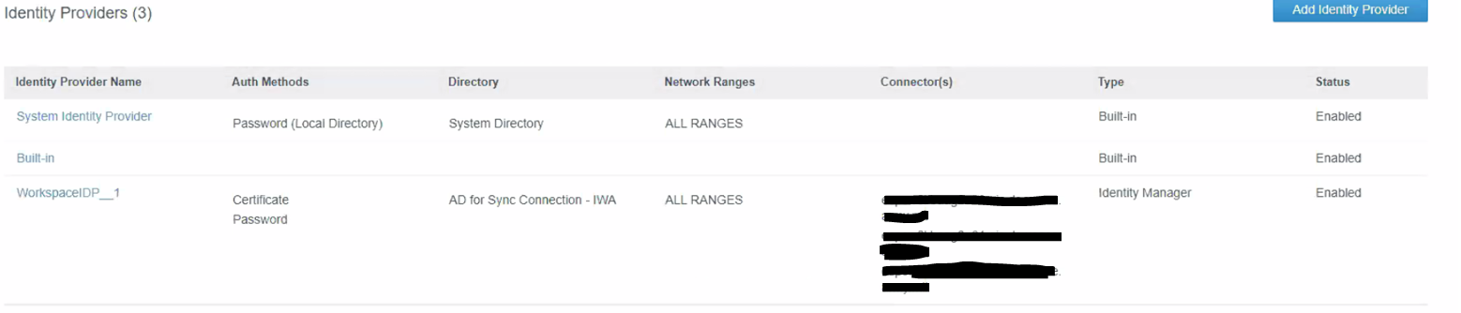

**Figure 8:** Identity Provider Configuration 1

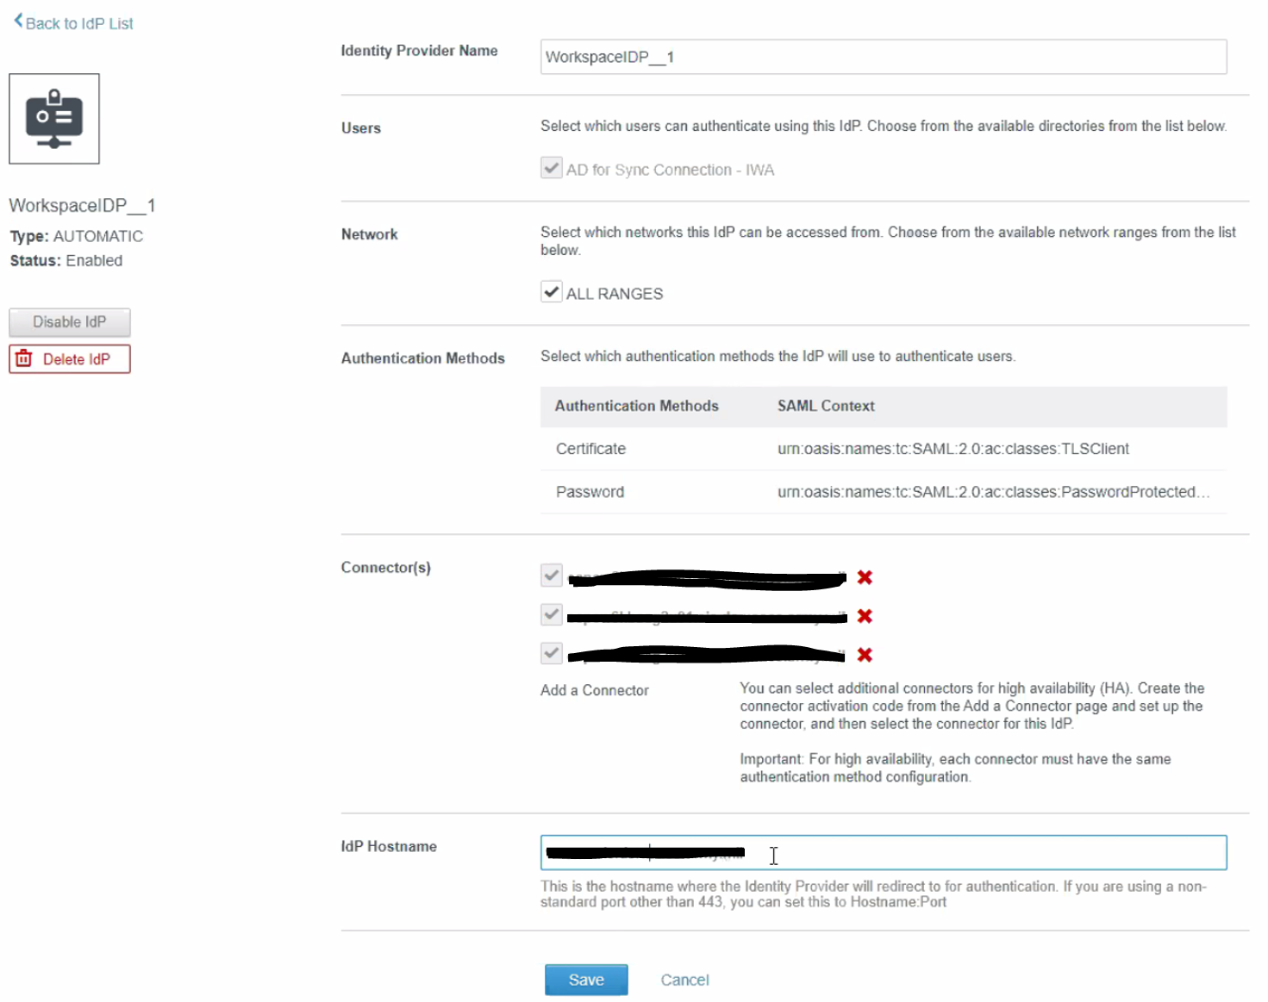

**Figure 9:** Identity Provider Configuration 2

## Test Login Process

You should now be able to login to vIDM and be shown the DoD login banner and be prompted for certificates from your Smart card.

# Troubleshooting

## Where are the Logs?

/opt/vmware/horizon/workspace/logs/connector.log

/opt/vmware/horizon/workspace/logs/horizon.log

## My browser is not prompting me for certificates

Verify your browser trusts the Root CA and chain for the vIDM certificate. If the browser does not trust the vIDM URL you are browsing to it will not present your certificates for selection.

## After HA Cluster scale-out of Workspace One Access, Smart Card (CAC) authentication fails.

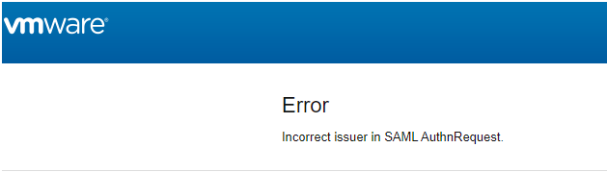

This is a bug with how vRealize Lifecycle Manager 8.x scales out an HA Cluster for Workspace One Access. Luckily there is a fairly simple way to permanently resolve the issue. This only impacts you if your customer has a pre-existing Workspace One Access/vIDM Linux appliance and you then go scale-out to an HA cluster using vRealize Lifecycle Manager.

The issue is that vRealize Lifecycle Manage in the scale-out process deploys the secondary appliances via an OVA but then attempts to copy all the pertinent settings from the primary node to the secondaries. While it does a good of this there is one area that has yet to be fixed in the code. And that is when users attempt to authenticate to the HA Cluster via any load balancer (with or without SSL Termination (both work)), users get a SAML error and the logs reveal little else.

* The Lifecycle Manager scale-out to turn vIDM into an HA cluster is somehow different than the way it's done without Lifecycle Manager.
* Lifecycle Manager did copy over all the certificates from the primary to the OVF deployed secondary nodes but something went wrong
* It turns out that the secondaries were unable to see the certs it said it had from UI and the config-state.json file thus causing auth issues
* It was only when clearing out the certs in the config-state.json file and then re-uploading the certificates that authentication worked.

The related Bugzilla details can be found here (VPN required):

* <https://bugzilla.eng.vmware.com/show_bug.cgi?id=2638633>
* <https://bugzilla.eng.vmware.com/show_bug.cgi?id=2633131>

The fix action is to do the following:

1. ssh to both the secondary appliances as root
2. stop horizon service:
   1. service horizon-workspace stop
3. cd /usr/local/horizon/conf/
4. copy the current config-state.json file before editing:
   1. cp config-state.json config-state.json.bak
5. Use ‘vi’ or ‘vim’ to edit the config-state.json file
   1. vim config-state.json
6. Now you need to search for the keyStore keyword with the following command:
   1. /keyStore
7. You are looking for “keyStoreFile” and “keystore” with all the certificates.
   1. For “keyStoreFiles” you should see something similar to this:
      1. 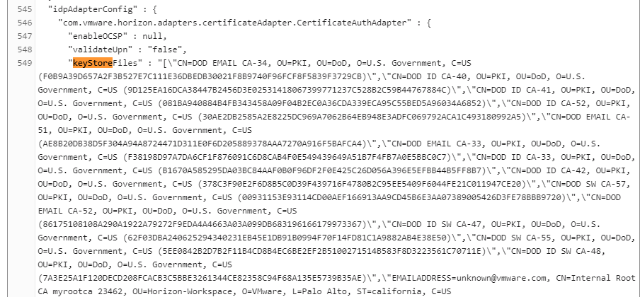
   2. But you must delete all the certificate entries so that is looks like this (below is the exact command and syntax):
      1. “keyStoreFiles” : “[]“,
   3. For “keystore” you should see something like this:
      1. 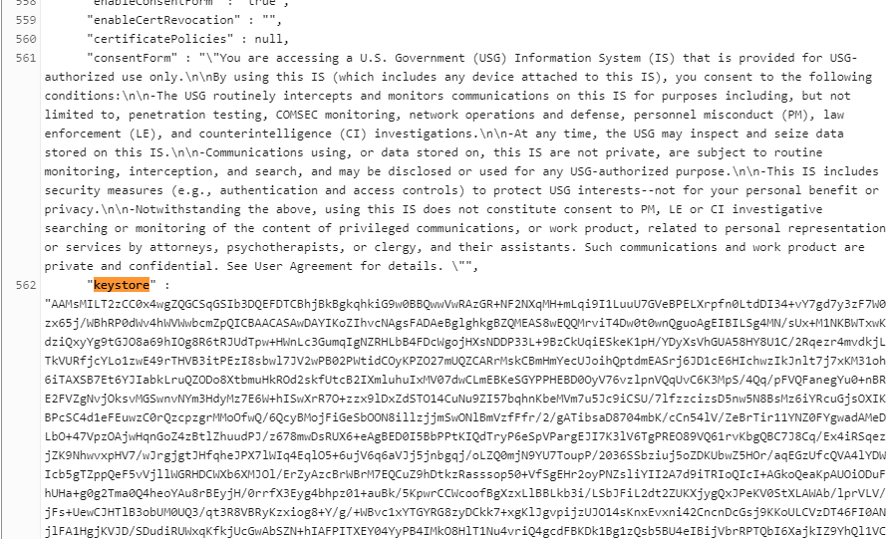
   4. But you must delete all entries so that it looks like this (below is the exact command and syntax):
      1. “keystore” : null,
8. Now save and close the file with the following commands:
   1. Press the ESC button
   2. :wq!
9. start horizon service: service horizon-workspace start
10. Wait about 3 minutes
11. Login to the individual node (appliance) you just edited via the web UI
12. Click on “Identity & Access Management” > “Setup” > “Connectors” > Click on the ‘Worker” for the secondary node you just edited.
13. Next Click “Auth Adapters” > “CertificateAuthAdapter”
14. Click on ‘Select File’ to re-upload all your DoD Root and Intermediate certificates. Also, if you are doing SSL termination then it would not hurt to upload your load balancer certificates as well.
    1. Example:
       1. 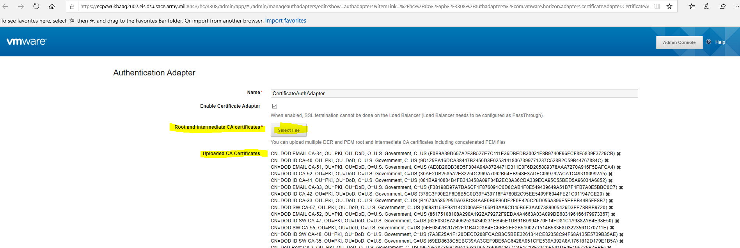
15. Now you can test CAC authentication and it should work.
16. DONE!

NOTE: If you can’t authenticate or things don’t look right then re-check your json file for typos. This method works.

# Glossary

|  |  |
| --- | --- |
| Smart Card/CAC | The CAC, a "smart" card about the size of a credit card, is the standard identification for active duty uniformed Service personnel, Selected Reserve, DoD civilian employees, and eligible contractor personnel. It is also the principal card used to enable physical access to buildings and controlled spaces, and it provides access to DoD computer network and systems. |
| User Principal Name | In Windows Active Directory, a User Principal Name (UPN) is the name of a system user in an email address format. A UPN (for example: john.doe@domain.com) consists of the user name (logon name), separator (the @ symbol), and domain name (UPN suffix). |
| PEM | Privacy-Enhanced Mail (PEM) is a de facto file format for storing and sending cryptographic keys, certificates, and other data, based on a set of 1993 IETF standards defining "privacy-enhanced mail." |
|  |  |
|  |  |
|  |  |
|  |  |
|  |  |